luc SWAT+ Toolkit

Help Documentation

Bangor University-CoESE

Alex Rigby

Table of Contents

1. Download 2

2. Set Up 2

2.1 SWAT+ Catchment Generation 2

2.2 Catchment Preparation for Toolkit 2

2.2.1 Importing a Catchment to the Toolkit 2

2.2.2 Zipping Shape Files 3

2.2.3 Simulation Run Time 3

2.2.4 Add the model exe files 4

2.3 Server Set Up 5

2.3.1 Python server set up 5

2.3.2 Launching servers 5

3 Using the Toolkit 6

3.1 Opening the Toolkit 6

3.2 Scenarios 7

3.2.1 Scenario Tab List 7

3.2.2 Default Scenario 7

3.2.3 Creating a New Scenario 7

3.3 Making Land Use Changes 7

3.3.1 Lasso selection 7

3.3.2 Land use change table 8

3.4 Making New Plant Community and Land Use 9

3.4.1 SWAT+ File Structure 9

3.4.2 Plant Community and Land Use Forms 9

3.4.3 Plant Community Input Fields 10

3.4.4 New Land Use Input fields 11

3.5 Running the Simulation 11

3.6 Visualization Controls and Model Comparison 12

3.6.1 Time Series Plot 12

3.6.2 Choropleth 12

# Download

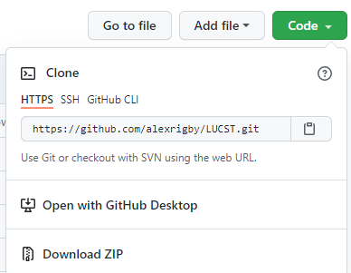

Download: https://github.com/alexrigby/LUCST

To download go to the GitHub link and under the dropdown ‘Code’ choose ‘Download Zip’. Extract the zipped files in a safe location on the machine you wish to run the toolkit from.

***Depending on the number of scenarios and size of catchment the folder can become large, to prevent complications save the SWAT_tool in a locatio not synced to drop box or any other cloud storage service.

# Set Up

## SWAT+ Catchment Generation

As its input data the toolkit requires:

* A properly calibrated SWAT+ catchment model
* The catchments associated shape files produced in QSWAT+

If you are not familiar with SWAT+ please visit the links bellow:

* SWAT+ download: [Installation - SWAT+ Documentation (gitbook.io)](https://swatplus.gitbook.io/docs/installation)
* A Useful short video series on getting started with SWAT+: <https://youtu.be/dBARtcejaPM>
* A useful SWAT+ calibration tool is SWAT+ Toolbox, download and documentation: [celray.github.io](https://celray.github.io/docs/swatplus_toolbox/introduction.html)/docs/swatplus_toolbox/introduction.html

***PLEASE NOTE*** The accuracy of the toolkit’s outputs are fully reliant on the accuracy of the original input SWAT+ model. To ensure an acceptable accuracy only properly calibrated catchments with an acceptable NSE (Nash Sutcliffe Efficiency) of 0.5 and above should be studied using the toolkit.

## Catchment Preparation for Toolkit

### Importing a Catchment to the Toolkit

To prevent accidental corruption of local files the ability to navigate and connect to local file systems was excluded from the toolkits interface.

To study a catchment in the toolkit, make a copy of the SWAT+ generated project folder and paste the copy into the ‘LUCST’ folder. Then rename the SWAT+ project folder ‘catchment’ (once all desired scenarios are studied the project can be copied out of the folder and renamed accordingly). See file structure:

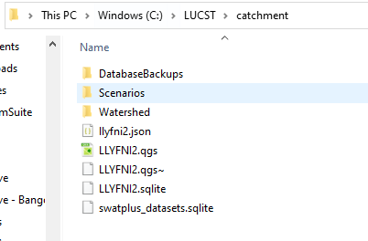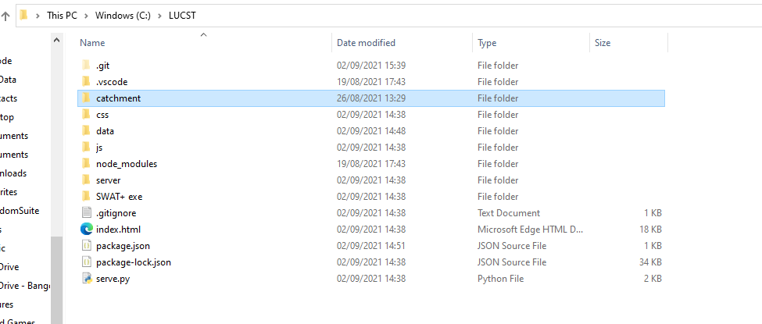

### Zipping Shape Files

The toolkit uses zipped shapefiles to generate the catchment layers on the map. Navigate to ‘LUCST\catchment\Watershed\Shapes’. Compress (zip) all files with the prefix’s:

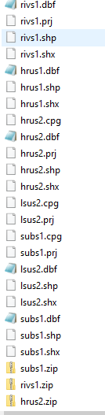

* ‘hrus2’ (hrus2.zip)
* ‘rivs1’ (rivs.zip)
* ‘subs1’ (subs1.zip)

To compress: With the files selected, right click the files, choose ‘send to’ and ‘compressed (zipped) folder’.

### Simulation Run Time

Before it is loaded in the browser the SWAT+ simulation must be run once. To maximise toolkit speed, it is recommended to run the simulation for a maximum of 2 years. To control model run time edit the ‘time.sim’ file found: ‘LUCST\catchment\Scenarios\Default\TxtInOut\time.sim’. ‘yrc_start’ represents the first year of the model, ‘yrc_end’ represents the last. See example:

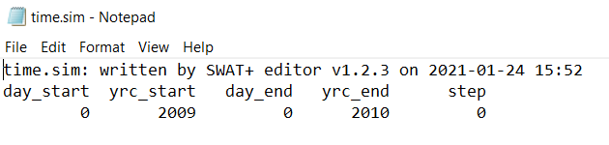

It is recommended to allow for 1-year warm up period (therefore 1-year printed data). The controls to print the monthly ‘hru_wb’ and daily ‘channel_sd’ in csv format also need to be selected. To select these controls, edit the ‘print.prt’ file found: ‘LUCST\catchment\Scenarios\Default\TxtInOut\print.prt’. See example:

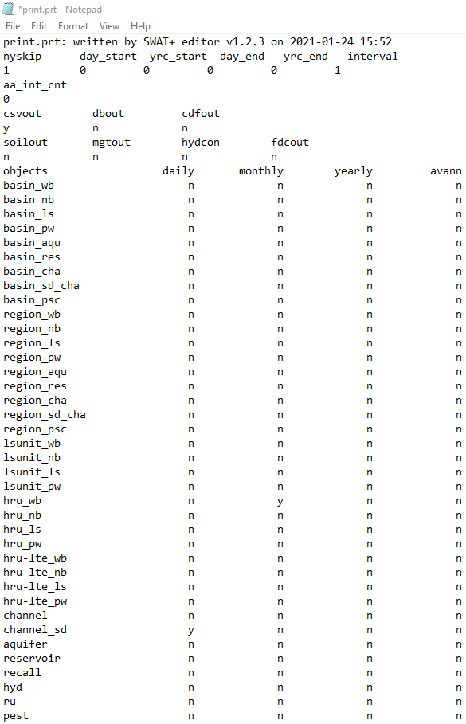

The model can be ran via SWAT+ Editor (downloaded with the SWAT+ model), SWAT+ Toolbox or using the exe files found in the ‘SWAT+ exe’ file (downloaded with this toolkit).

### Add the model exe files

Finally, copy and paste the two .exe files from the ‘SWAT+ exe’ folder (downloaded with LUCST) into ‘LUCST\catchment\Scenarios\Default\TxtInOut’. These executable files are used to run the model.

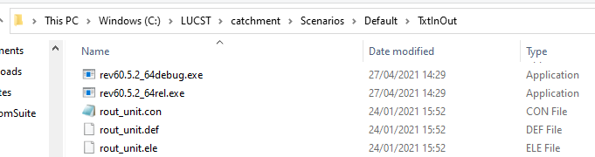

*** LUCST runs with ‘rev60.5.2_64rel’ of SWAT+. This can be changed by altering the config file at ‘\LUCST\server\config.js’. ***IMPORTANT:*** *LUCST is a small personal development and is not updated regularly therefore it is not guaranteed that revisions to SWAT+ in later releases work as expected through the toolkit.*

## Server Set Up

### Python server set up

To run the toolkit locally a Python server is utilized. Therefore, Python needs to be running the local machine. Download the latest version of Python from [Download Python | Python.org](https://www.python.org/downloads/) and follow the instillation steps.

## Launching servers

Open Windows PowerShell and navigate to the toolkit location by typing ‘cd “file location…..\LUCST*”’* and pressing enter. Launch the server by typing ‘npm run swat-server’ and pressing enter on the keyboard.

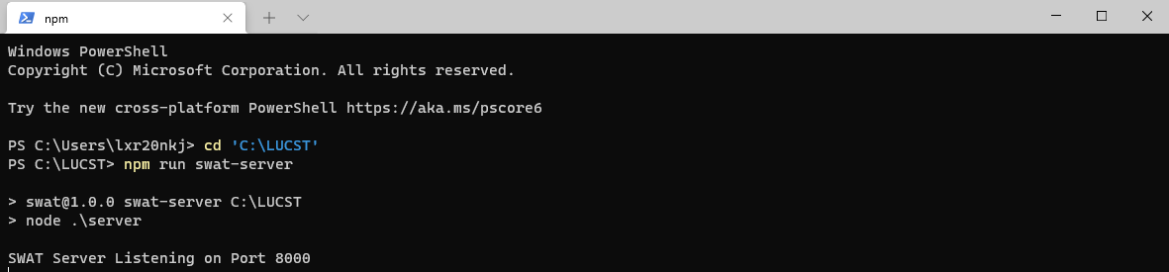

In a new PowerShell tab navigate to the file location again. Launch the Python server by typing ‘npm run swat’' hitting enter on the keyboard.

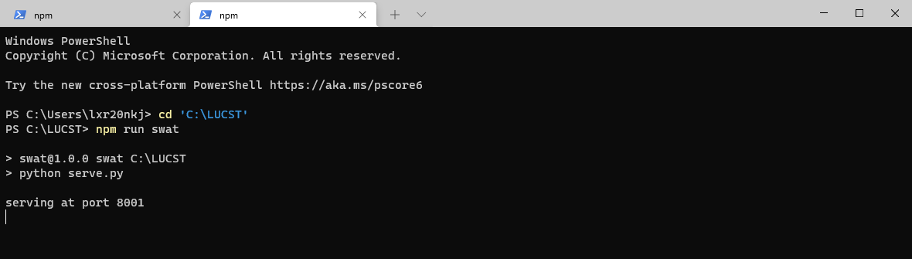

***If you don’t have Windows PowerShell downloaded either download from: [Download Windows PowerShell 4.0 and Other Quick Reference Guides from Official Microsoft Download Center](https://www.microsoft.com/en-gb/download/details.aspx?id=42554) OR use the command line by searching ‘CMD in the windows search bar. If using the CMD line a new window will be needed for each server.

# Using the Toolkit

## Opening the Toolkit

The toolkit should now be running on the server port 8001 on your local machine (step 2.3). To launch the toolkit, open your preferred browser and search ‘localhost:8001/?dev=1*’* in the search bar. The toolkit should now open with your SWAT+ catchment displayed in the map window. See example:

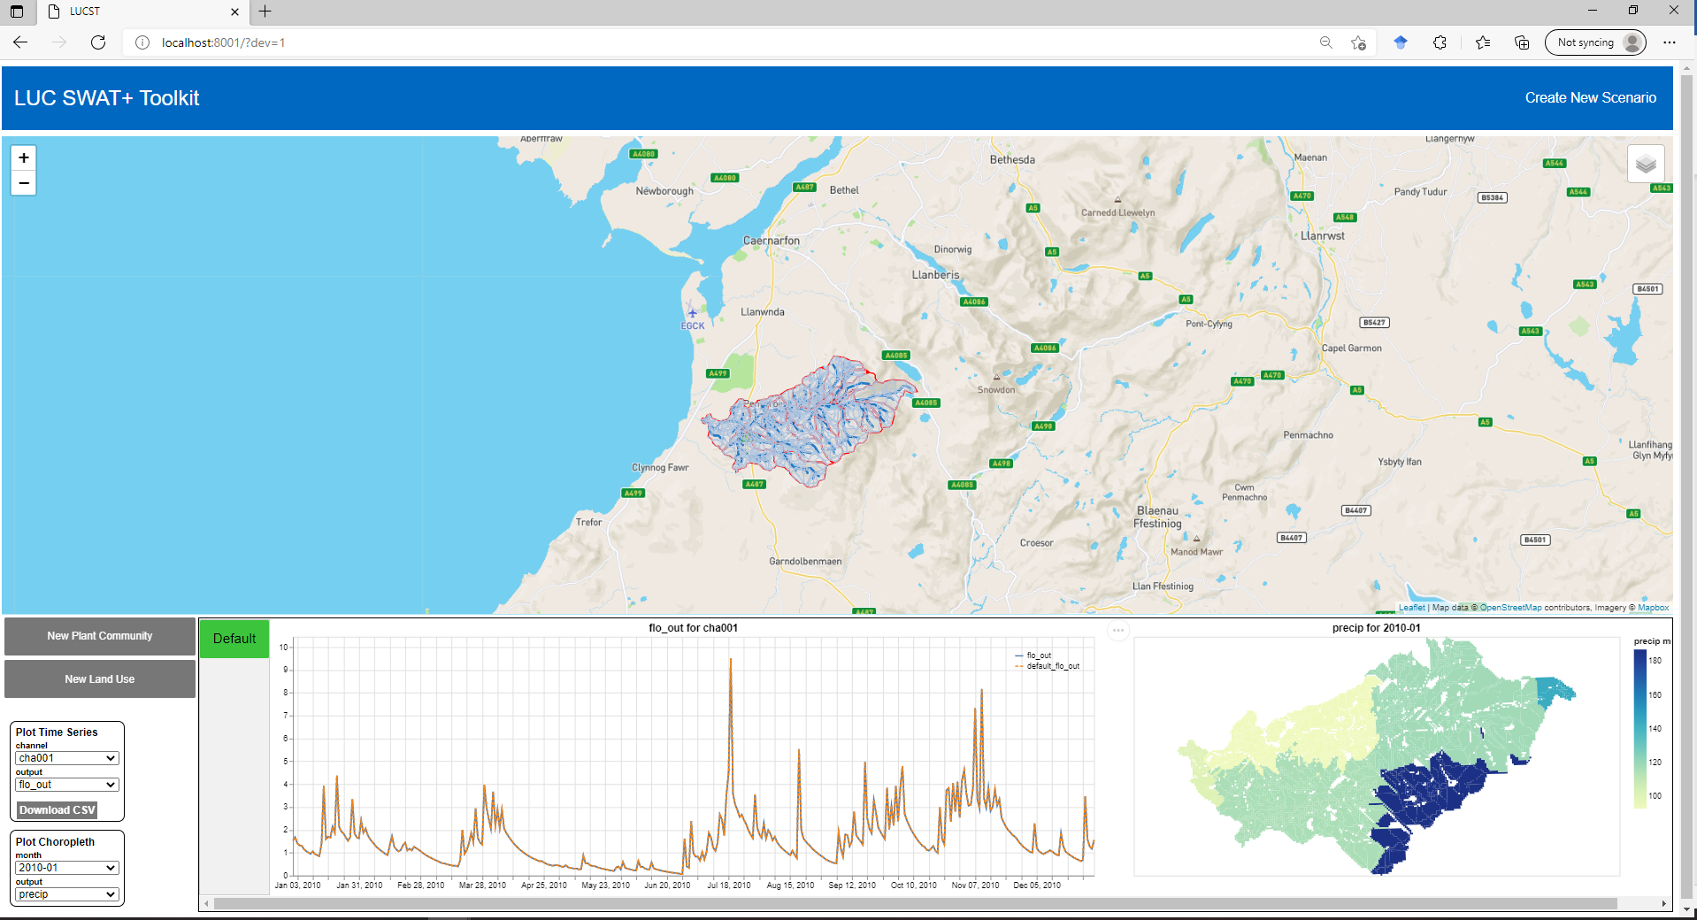

## Scenarios

### Scenario Tab List

The grey sidebar to the left of the time series and choropleth plots in the lower half of the page is the scenario tab list. All scenarios for your catchment will display in this list. When a scenario is selected (highlighted green) the entire window will display the data of the current scenario. Any changes made when a scenario is selected will save to that scenario (therefore changes can be overwritten).

### Default Scenario

When the toolkit loads the ‘Default’ scenario is selected as the current scenario, therefore all data displayed is from ‘Default’.

The ‘Default’ scenario is created by SWAT+ when the catchment is defined (section 2.1). ‘Default’ represents the current state of the catchment and must remain unchanged to be used as a baseline scenario for comparison.

To avoid making changes to ‘Default’ all functions which allow changes to be made are disabled when ‘Default’ is selected. Visualization controls are enabled as these are ‘passive’, i.e. read, but do not alter the SWAT+ files.

### Creating a New Scenario

To create a new scenario click ‘Create New Scenario’ (top right of page). This will prompt you with a pop-up window with an automatically assigned new scenario name (different scenario name can be chosen). Click ‘ok’ to make the new scenario. The new scenario should appear in the scenario tab.

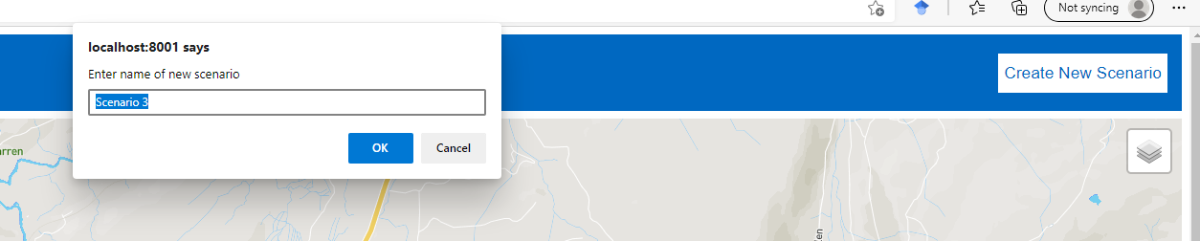

The new scenario is an exact copy of the ‘Default’ scenario and will now appear in your catchment file ‘LUCST\catchment\Scenarios’.

## Making Land Use Changes

### Lasso selection

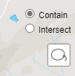When not in ‘Default’ the lasso controls will appear in the top right of the map. Choose between the ‘contain’ and ‘intersect’.

To make a selection, click the lasso icon in the top left of the map, the cursor will turn into cross head indicating the ‘lasso tool’ is activated. Press and hold the mouse on the map and either circle or intersect an area, release the mouse when the selection is made. The selected layers will turn red and the land use change table will generate to the right of the map.

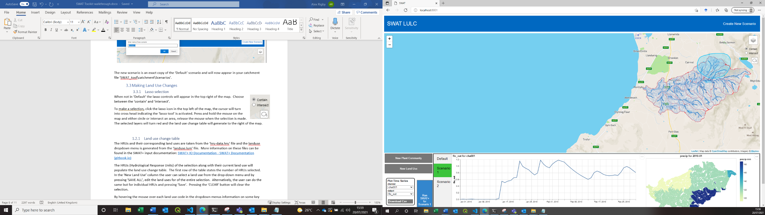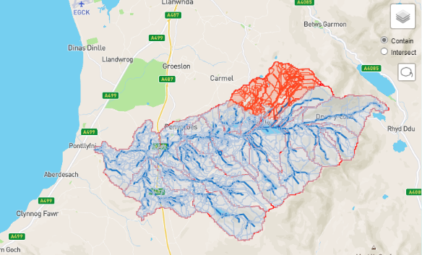

### Land use change table

Selected HRUs along with their current land use populate the land use change table (pop-up to the right of the map once a selection is made).

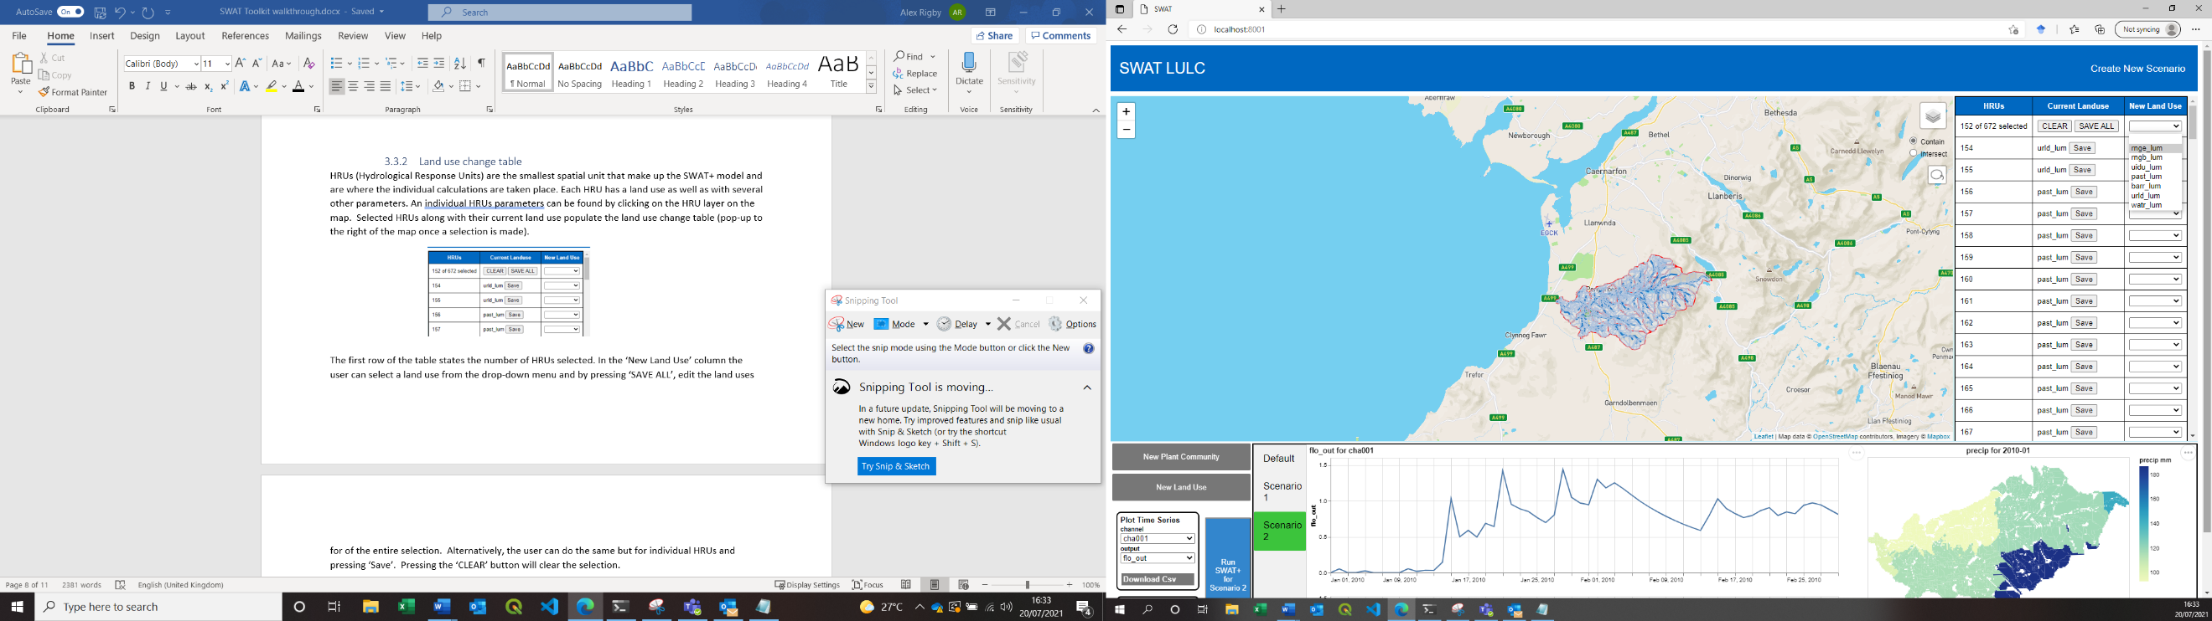

In the ‘New Land Use’ column select a land use from the drop-down menu, click ‘SAVE ALL’ in the top row to change the land uses for of the entire selection. Alternatively, do the same but for individual HRUs and pressing ‘Save’. Pressing the ‘CLEAR’ button will clear the selection.

***IMPORTANT:*** *The land uses you see in the drop-down menu are limited to the existing land uses in the catchment. If you wish to create a new land use that does not exist in the catchment, please perform the steps described in Section 3.3 and then repeat the above Lasso procedure.*

Hover the mouse over a land use code in the dropdown menu to display some of its defining parameters.

The HRUs ‘id’ and corresponding land use are taken from SWAT+’s ‘hru-data.hru’ file and the land use dropdown menu is generated from the ‘landuse.lum’ file. More information on these files and their parameter codes can be found in the SWAT+ input documentation: [SWAT+ IO Documentation - SWAT+ Documentation (gitbook.io)](https://swatplus.gitbook.io/docs/user/io)

***HRUs (Hydrological Response Units) are the smallest spatial unit that make up the SWAT+ model and are where individual calculations take place. Each HRU has a land use as well as several other parameters. An individual HRUs parameters can be found by clicking the HRU layer on the map.

## Making New Plant Community and Land Use

### SWAT+ File Structure

The SWAT+ model runs by reading codes from files which are defined in connected files. The top-level file is ‘hru-data.hru’ which contains codes defining each HRU. When making land use changes to ‘hru-data.hru’ two other files are important: ‘landuse.lum’ and ‘plant.ini’.

The land use of a HRU is stated in ‘hru-data.hru’ under lu_mgt (land use management). All land use codes are defined in the ‘landuse.lum’ file. In turn, the plant community of a land use is stated in ‘landuse.lum’ under plt_com (plant community). All plant community codes are defined in the ‘plant.ini’ file.



When the catchment is first set up in SWAT+ (section 2.1) the land uses and plant communities which are present in its current state are added to these files. To incorporate new land uses and plant communities to the catchment they first need to be written to the corresponding files.

### Plant Community and Land Use Forms

To make a new plant community or landuse type click the ‘New Plant Community’ button or the ‘New Land Use’ button respectively (bottom left of the page) to open up the pop-up forms. Some of the input fields have default values for ease of use but can be changed if required. Each input field must be filled in. Click ‘make’ to write the new plant community to the plant.ini file or land use to ‘landuse.lum’. Click ‘reset’ to clear the forms. Click on the map area to close both forms.

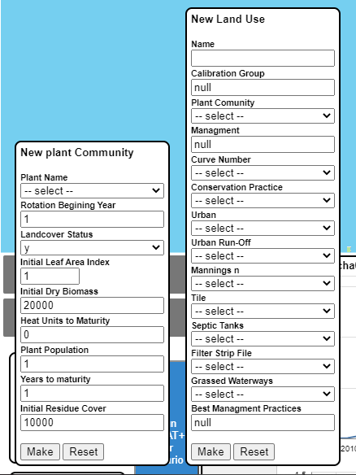

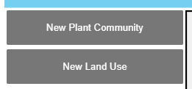

For each input field drop down list a short description of each code in the list is displayed when the mouse is hovered over it. For a more in depth description of all the input variables refer to the SWAT+ input documentation: [SWAT+ IO Documentation - SWAT+ Documentation (gitbook.io)](https://swatplus.gitbook.io/docs/user/io) .

### Plant Community Input Fields

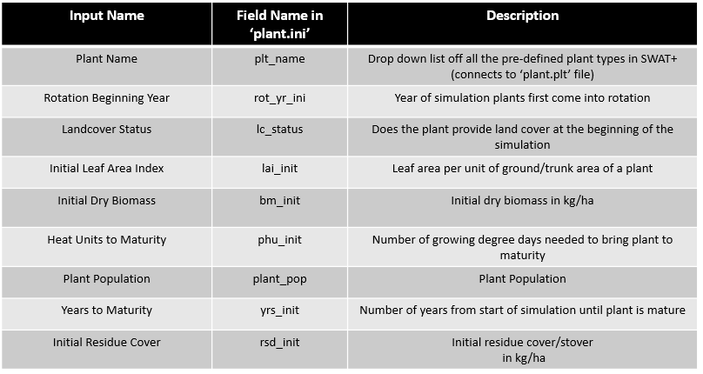

***values for the ‘pcom_name’ and ‘plt_cnt’ fields in ‘plant.ini’ are automatically set to the plant name + ‘_comm’and 1 respectively. At the current stage of development, the toolkit doesn’t have the complexity to add multiple plants to each plant community so there is no use in giving the user control over those variables.

### New Land Use Input fields

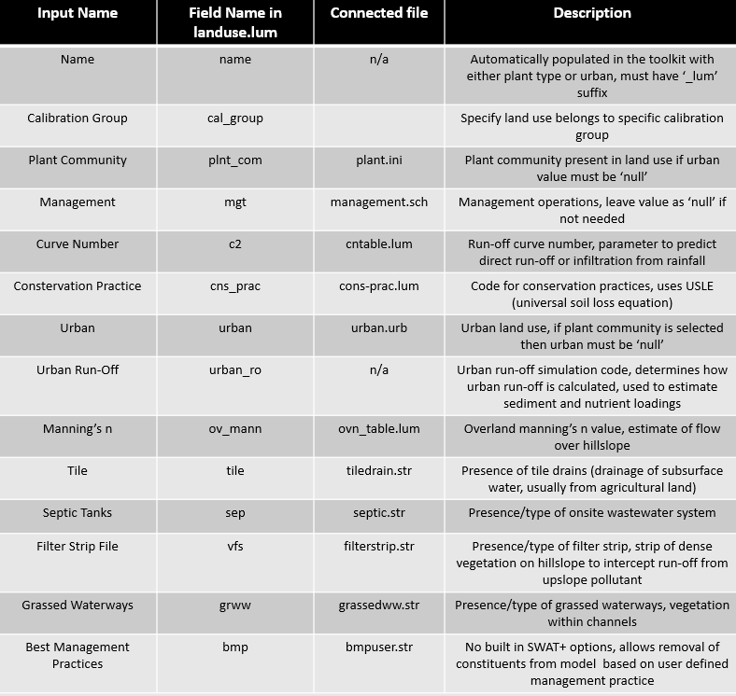

## Running the Simulation

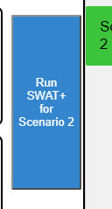Once all desired changes have been made click the blue button to the left of the scenario tab ‘Run SWAT+ for (scenario name)’. A spinner will appear indicating that the model is running. Depending on the size of the catchment and length of simulation this could take several minutes.

## Visualization Controls and Model Comparison

Data for the time series plot is taken from the SWAT+ output file ‘channel_sd_day’, data for the choropleth is taken from ‘hru_wb_mon’. Descriptions of the plottable data from these files can be found in the SWAT+ output documentation: [SWAT+ IO Documentation - SWAT+ Documentation (gitbook.io)](https://swatplus.gitbook.io/docs/user/io).

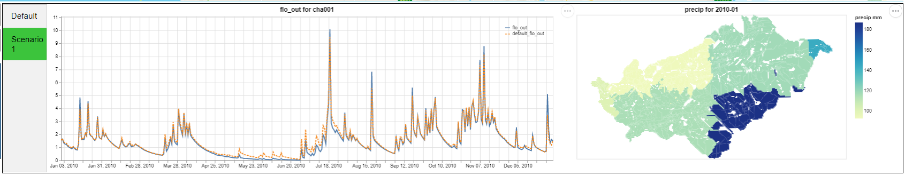

### Time Series Plot

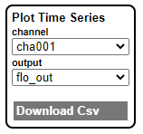A hydrograph (flo_out vs time) for the main channel is plotted by default when the page loads. By selecting from the dropdown lists in the ‘Plot Time Series’ box (bottom left) a plot for any of the channels and any of the ‘channel_sd_day’ outputs can be generated.

Data for the current scenario is plotted with a blue line and the same data for the ‘Default’ scenario is plotted with an orange dashed line for comparison of outputs. If no changes have been made to the current scenario then the lines will be plotted on top of one another.

The raw CSV data for the current plot can be downloaded by pressing the ‘Download CSV’ button in the ‘Plot Time Series’ box. Alternatively, and SVG and PNG can be downloaded by pressing the three grey dots to the top right of the plot.

### Choropleth

Precipitation for the first month of the model is plotted when the page first loads. Like for the time series plot, by selecting from the dropdown lists in ‘Plot Choropleth’ any of ‘hru_wb_mon’ outputs for any of the model months can be plotted. An SVG and PNG of the choropleth can be downloaded by clicking the three grey dots to the top right of the choropleth.

***to identify a specific channel, click on the channel on the map and a pop up will appear, the ‘Channel’ value is the id of that channel and can be selected in the visualization drop down option lists.